date.m:

g=9.8;

R=2;

v0=sqrt(4.01*g*R);

m=4;

system_f.m:

function [ f] = sistem_f(t,q)

%UNTITLED3 Summary of this function goes here

% Detailed explanation goes here

f=zeros(2,1);

date;

f=[q(2);-g*sin(q(1))/R];

end

pendul.m:

date;

[t,q]=ode45(@sistem_f,[0;10],[0;v0/R]);

teta=q(:,1);

N=3*m*g*cos(teta)-2*m*g+m*v0^2/R;

x1=R*cos(teta);

x2=R*sin(teta);

figure(1)

plot(x1,x2,'.','Markersize',6)

title('Pendulul matematic')

xlabel('x1')

ylabel('x2')

grid on

figure(2)

title('Pendulul matematic')

xlabel('x1')

ylabel('x2')

grid on

for i=1:size(teta,1)

plot(x1(i),x2(i),'*',-R,-R,'o',R,R,'o');

axis equal

hold on

M(i)=getframe;

end

movie(M,3,10)

figure(3)

plot(t,N)

title('Reactiunea N')

xlabel('t')

ylabel('N')

grid on

figure(4)

plot(t,teta)

title('Unghiul teta ca functie de t')

xlabel('t')

ylabel('teta')

grid on

**Pentru v0=sqrt(2*g*R):**

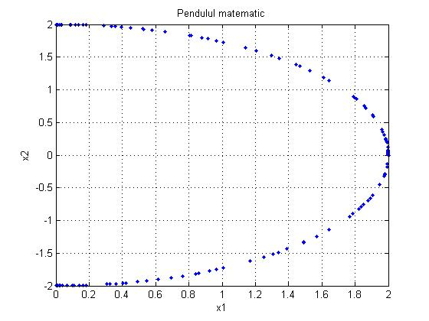

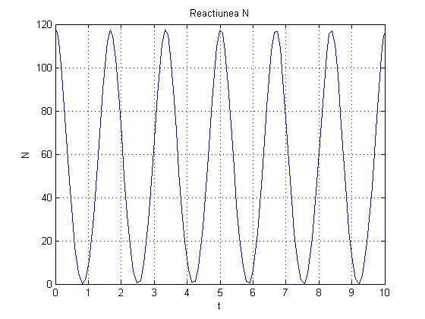

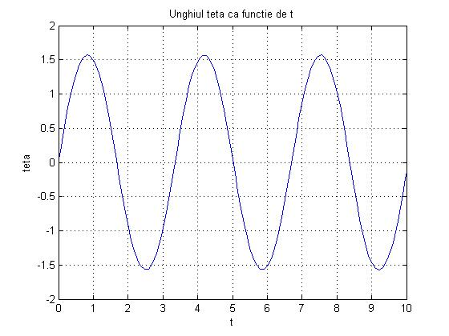

**Pentru v0=sqrt(3*g*R):** 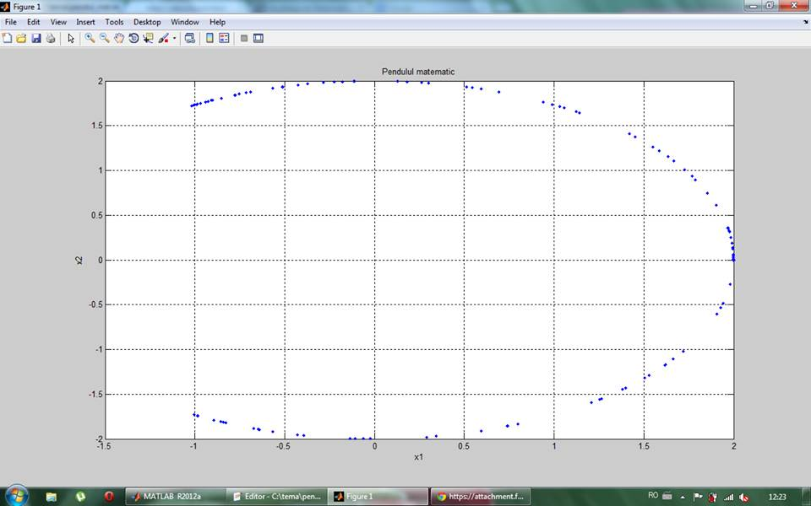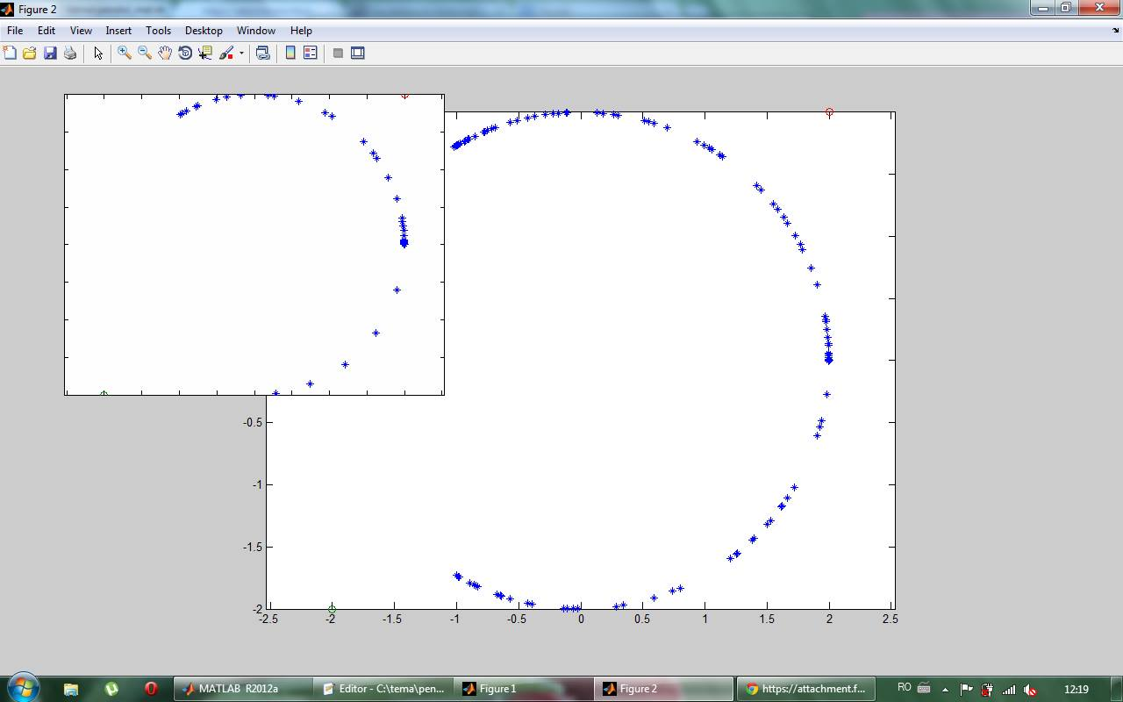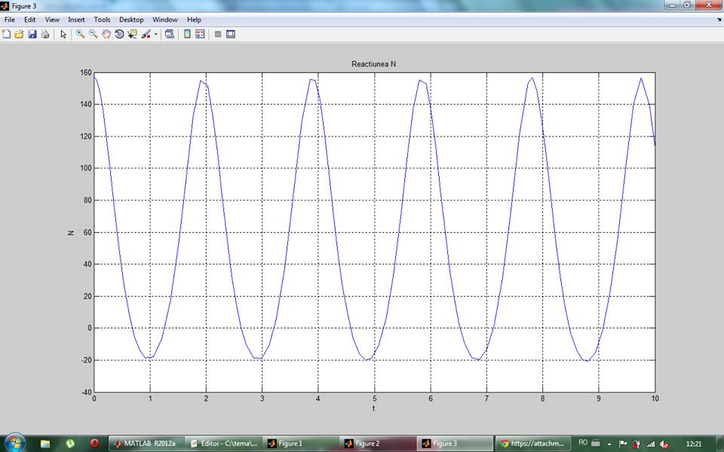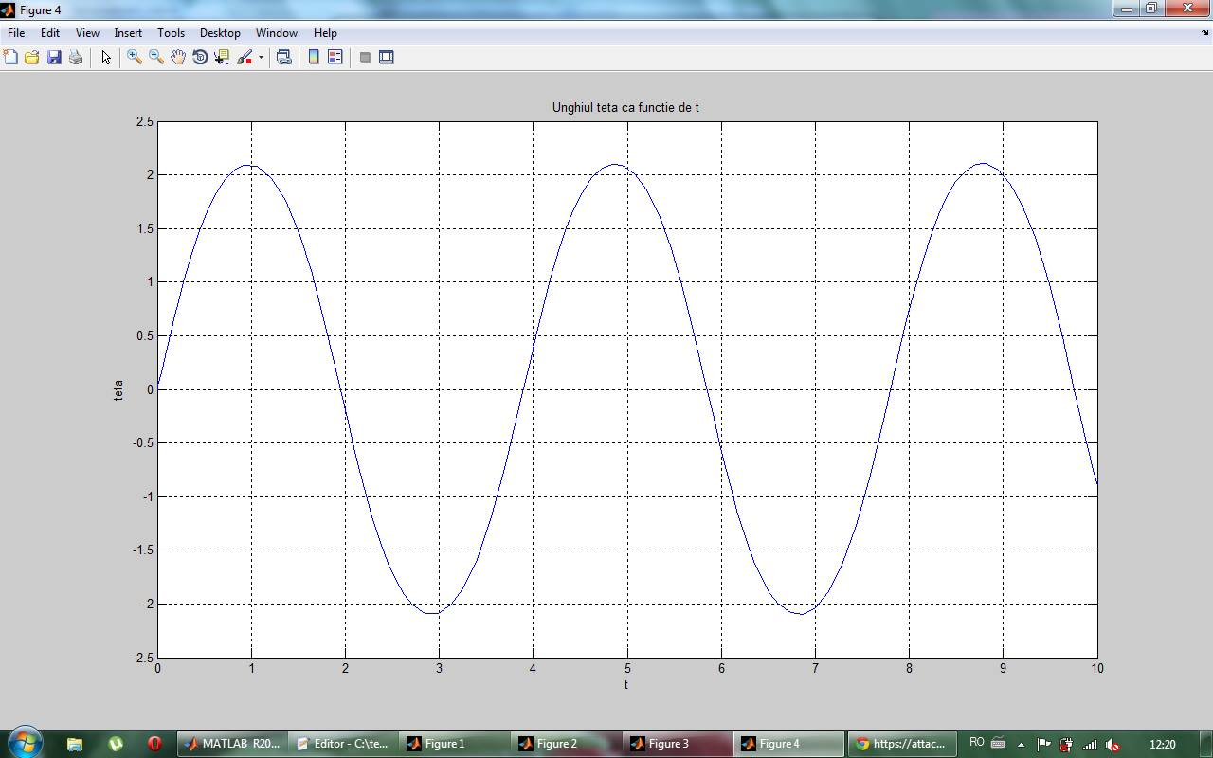

Pentru v0=sqrt(4.01*g*R):

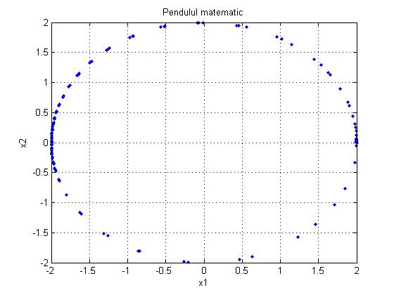

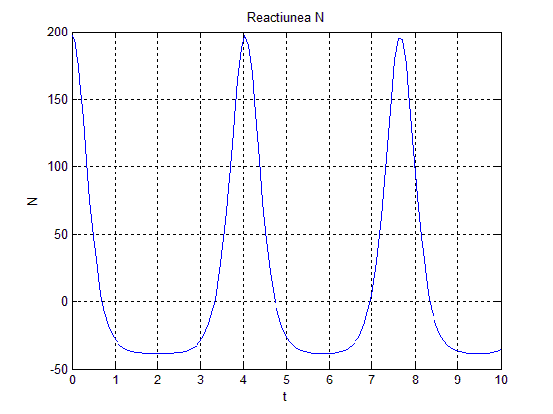

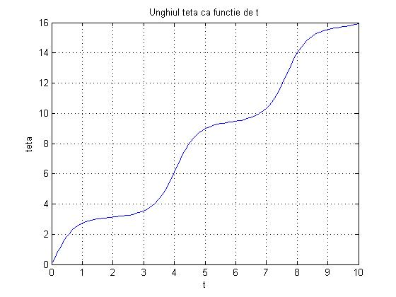

Pentru v0=sqrt(5*g*R):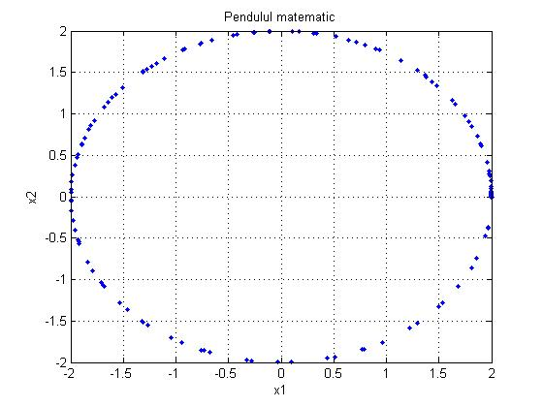

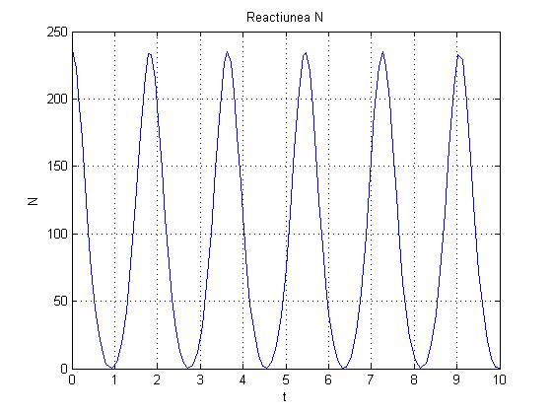

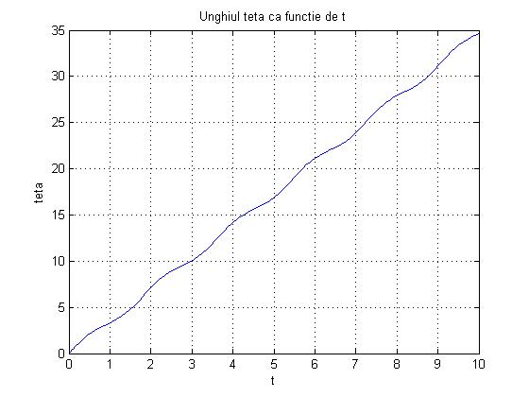

**Pentru v0=sqrt(6*g*R):**

